**Task 1**. *Fill in the gaps with the expressions from the box:*

|  |
| --- |
| feel free to interrupt me * demonstrate how to * I’ll go through * as you can see here *  do that by creating * so let’s see how * what you need to do is * similarly we can |

1. [video 1](https://youtu.be/RfJuigJebRg?t=1106)

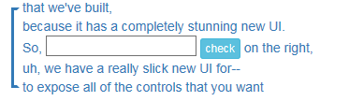

2. [video 2](https://youtu.be/kXvA5CqGPbI?t=20)

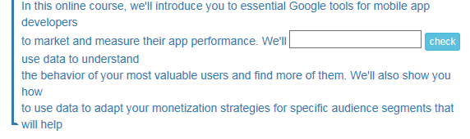

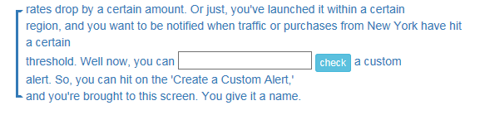3. [video 3](https://youtu.be/NWwVj_X0WxY?t=1388)

4. [video 4](https://youtu.be/88DUIFM_nng?t=262)

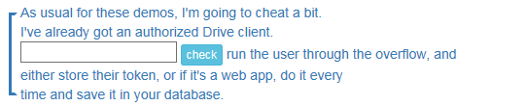

5. [video 5](https://youtu.be/ICNjRS2X8WM?t=115)

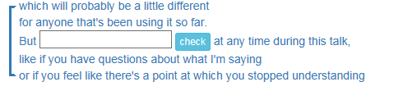

6. [video 6](https://youtu.be/wJL1oW6DlCc?t=73)

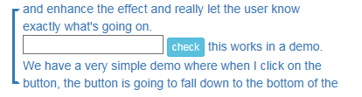

7. [video 7](https://youtu.be/5onKZcJyJwI?t=388)

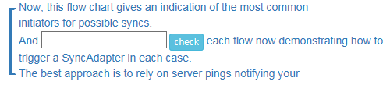

8. [video 8](https://youtu.be/fKZ-jld-hbA?t=960)

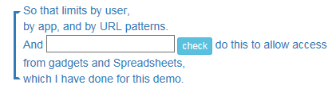

*Now watch the videos and check your answers.*

**Task 2.***Prepare and record a demo of an application/program that you regularly use and know quite well. You will have to share your screen so that you can show how the app/program works.*

*The demo should be 3-5 minutes long. Please make sure it has introductory, main and closing parts. Use the language from the lesson.*

*You will need to send the file to/share it with your teacher.*